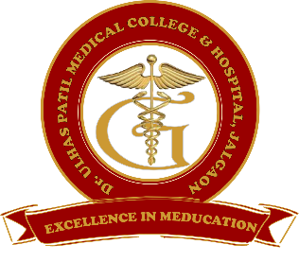**Godavari Foundation’s**

**DR. ULHAS PATIL MEDICAL COLLEGE & HOSPITAL,**

**Recognized by Medical Council of India, Approved by Central Govt. of India, New Delhi,**

**Letter no. MCI-34(41)/2012-med./158127, dated 05/02/2013**

**Affiliated to Maharashtra University of Health Sciences, Nashik [College Code-1306]**

**Jalgaon-Bhusawal Road, NH-6, JalgaonKh, Tal.& Dist. Jalgaon 425309**

**Tel. No. (0257)2366657, 2366678 Fax No. 0257-2366648**

**Email ID :[dupmcj@yahoo.in](mailto:dupmcj@yahoo.in) Web Site :** [**www.dupmc.ac.in**](http://www.dupmc.ac.in)

**5.1.4 The Institution has an active international student cell to facilitate study in India program etc..,**

International student cell at Dr. UlhasPatil Medical College & Hospital JalgaonKh. provides various kinds of experiences in Indian Hospital, Healthcare system and medical college/academics for students from foreign countries seeking to obtain medical Education in India. The student friendly atmosphere of campus and friendly nature of staff makes it easy for international students of various cultural backgrounds to easily settle in the campus. The International Students Cell is headed by Dr.Narayan Arvikar as an Officer and Milind for clerical support. Both of these interact with Heads of Departments of various disciplines and with students.

The International Student cell conducts biannual meetings with all HODs and members of Student council to discuss new opportunities and plan strategy for its implementation

**OBJECTIVES ARE:**

* To offer medical course, short term observation or Hands – on courses and long term fellowships to international students desirous of obtaining education in India
* To provide optimal support to these students by means of online application process.
* Offer support for visa processing, online payment of Tution Fees, and completion of police registration process.
* To provide support through Language support, Accommodation and food knowledge of Local transportation system and healthcare facilities.
* Provide and look after medical insurances and Treatment of various illnesses that Student may suffer in course of his/her study tenure.
* To promote interest of our college students for abroad learning via student Exchange Programs.
* To provide counseling support to students desirous of perusing higher studies in international universities, or abroad.
* To educate students about the various opportunities for higher studies, and help them in admission process for the same by interaction with other international or foreign institutes.
* To maintain above and success data in student section Cell.